**How to create the angular project and Hello World application**

Open the visual studio code application->

Go to terminal->

Click on New Terminal->

Will display command prompt on screen

type ng new sample(Project name)

Then it will ask for two questions

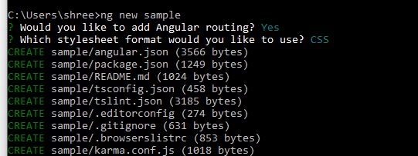

Would you like to add angular routing? Type yes

Which stylesheet format would you like to use? Type css

Then it will takes time to create the new project.

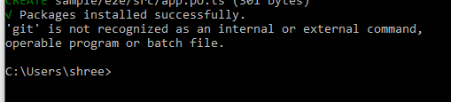

Go to file->open folder->select the created project-> click on open button then will see into visual studio code looks like as below

Project will be open into visual studio code.

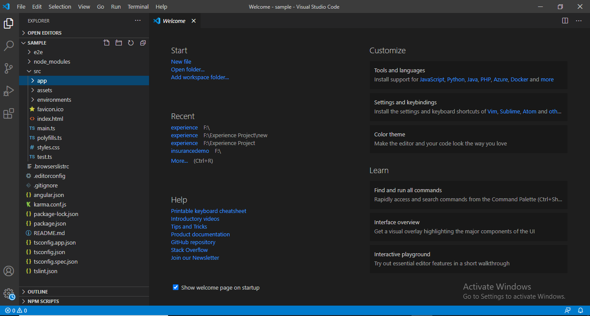

Go to terminal-> New Terminal->will open command prompt as below.

How to compile angular project

ng serve

How to run angular project

then go to browser and type <http://localhost:4200/> or

Output-

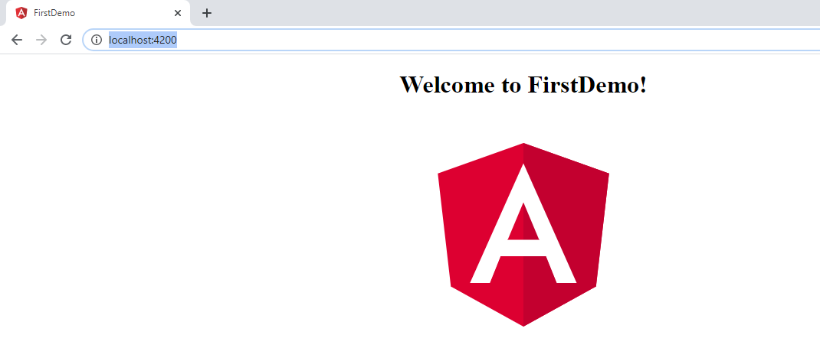

**Angular Package Structure-**

E2E folder- contain source of file to perform set of end to end test that correspond to root level application along with test specific configuration files.

Node module folder- contain set of npm package for entire workspace

Src folder- contain set of source file that are required for your application development.

Edit config folder- specifies the configuration

Angular.json folder- CLI configuration default for all the projects in the work space.

App folder – contain the component file in which application logic is present.

Assests- contain the images when you build the application.

Environment folder- target environment file

Index.html- this is the main page of application when someone visits to your site.

Main.ts - this is the entry point of your application

app/app.component.ts-Defines the logic for the app's root component, named AppComponent. The view associated with this root component becomes the root of the view hierarchy as you add components and services to your application.

app/app.component.html -Defines the HTML template associated with the root AppComponent.

app/app.component.css-Defines the base CSS stylesheet for the root AppComponent.

app/app.component.spec.ts-Defines a unit test for the root AppComponent.

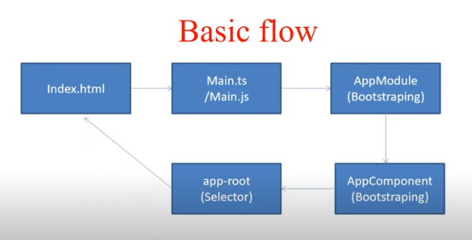

Explaination-

Main.ts->app.module.ts->app.component.ts->will call app.component.html and app.component.css file when loading ts file-> check the seletors(app-root)- go to index.html because we write there <app-root>